4CS015 – Portfolio Task #4
STUDENT NAME: Nayan Raj Khanal
STUDENT NUMBER: 2227486
You will need to complete the workshop and then submit this Word file, complete with your answers, via Canvas, by the end of the Semester (week 12).
For this assignment (workshop) you will show how to navigate and create file systems from command prompt in both Windows (os) and Linux(os), also how to make a batch file to be executed in the Windows (os).
NOTE: Please make sure you have written your command and the screenshot of the commands. Failure to do so will result in a mark deduction.
Task 1 (Windows Command Line)
- Write a command to create a directory "test"
mkdir test
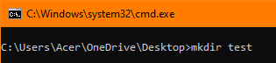
- Write the command to list all the directories/files inside the directory test
dir test
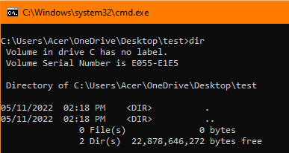

- Create a file "hello.txt" containing the word "Hello", inside the test directory.
copy con "hello.txt"
Hello
#Ctrl+c
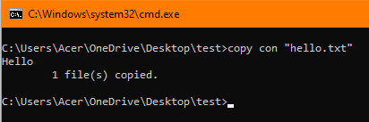
- Display the content of hello.txt in the command line.
type “hello.txt”
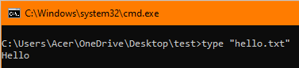

- Make directory test1 on the Desktop and copy hello.txt from test to test1
mkdir test1
cd test
copy "hello.txt" C:\Users\Acer\OneDrive\Desktop\test1
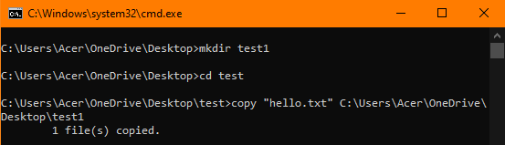

- Now delete the file hello.txt in the current directory
del /f hello.txt
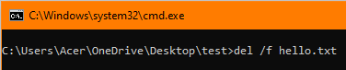
- Write a command to display your current directory.
cd
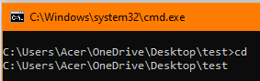

- Now rename the file to hello2.txt
rename "hello.txt" "hello2.txt"
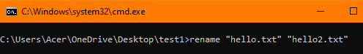

- Now navigate outside the directory test.
cd..
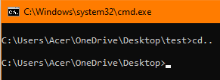

- Write the command to print the tree structure. It should look something like this:
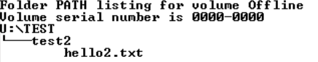
mkdir test2
cd test2
copy con “hello2.txt”
Hello
#Ctrl+c
cd..
tree /f
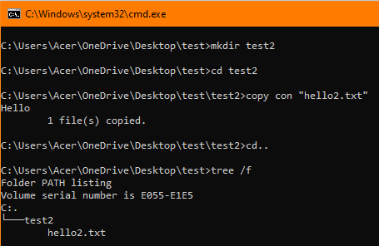

Task 2
Create the following directory structure and paste it after this picture. (15 marks):
Note: MYMODULES must be inside <your_name> directory.
Make a directory with your name on the desktop and navigate to the directory before you display the following structure.

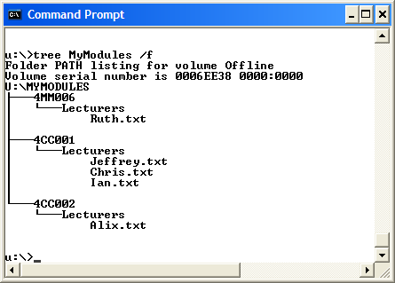

[Insert your picture here]
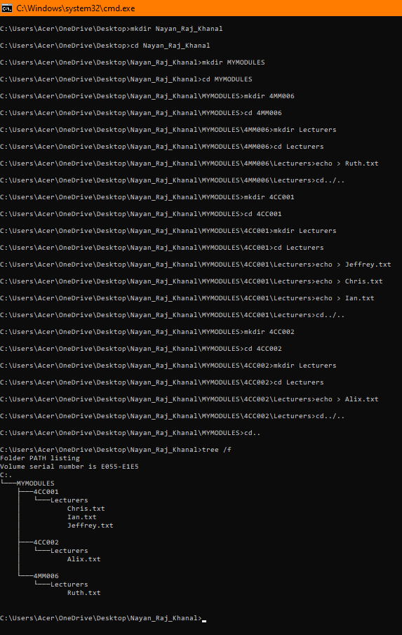
*Commands:*
mkdir Nayan_Raj_Khanal
cd Nayan_Raj_Khanal
mkdir MYMODULES
cd MYMODULES
mkdir 4MM006
cd 4MM006
mkdir Lecturers
cd Lecturers
echo > Ruth.txt
cd../..
mkdir 4CC001
cd 4CC001
mkdir Lecturers
cd Leturers
echo > Jeffery.txt
echo > Chris.txt
echo > Ian.txt
cd../..
mkdir 4CC002
cd 4CC002
mkdir Lecturers
cd Lecturers
echo > Alix.txt
cd../..
cd..
tree /f

Task 3(Linux terminal) (10 marks)
Now, Boot into Linux operating system in VirtualBox or Windows-SubSystem for Linux(On Windows)
- Write a command to create a directory "test"
mkdir test
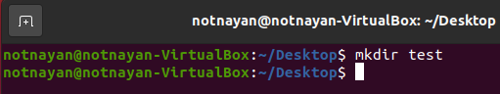

- Write the command to list all the directories/files inside the directory test
dir
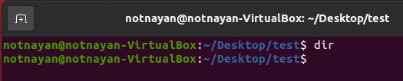
- Create a file "hello.txt" containing the word "Hello", inside the test directory.
echo “Hello” > hello.txt
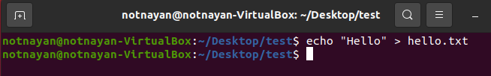
- Display the content of hello.txt in the command line.
cat “hello.txt”
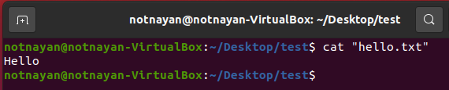
- Make directory test1 on the Desktop and copy hello.txt from test to test1
mkdir test1
cp /home/notnayan/Desktop/test/”hello.txt” /home/notnayan/Desktop/test1
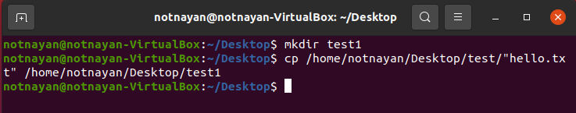

- Now delete the file hello.txt in the current directory
rm “hello.txt”
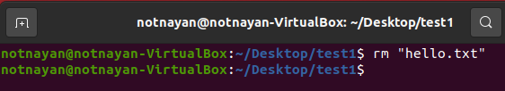
- Write a command to display your current directory.
pwd
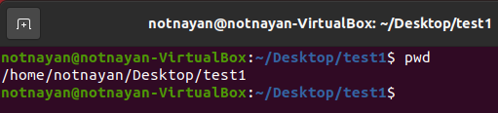
- Now rename the file to hello2.txt
mv “hello.txt” “hello2.txt”
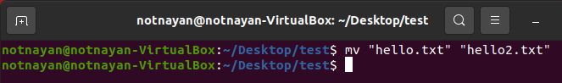
- Now navigate outside the directory test.
cd ..
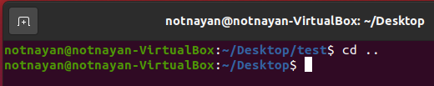

- Write the command to print the tree structure.
tree
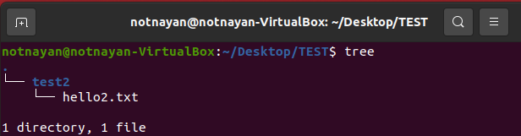

Task 4
Create the following directory structure (identical to the one that you created in Windows Command Prompt):
Note: MYMODULES must be inside <your_name> directory.
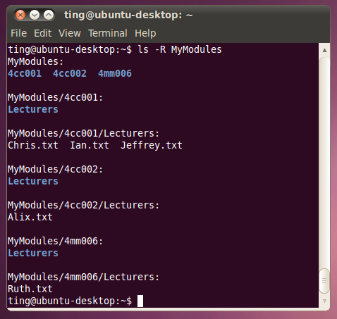
and insert it below (15 marks):
[Insert your picture here]
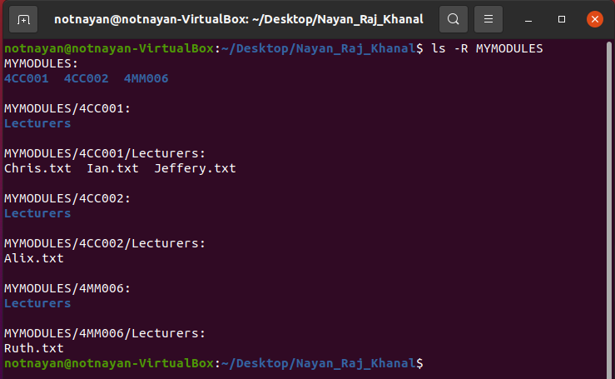
*Commands:*
mkdir Nayan_Raj_Khanal
cd Nayan_Raj_Khanal
mkdir MYMODULES
cd MYMODULES
mkdir 4MM006
cd 4MM006
mkdir Lecturers
cd Lecturers
touch Ruth.txt
cd ../..
mkdir 4CC001
cd 4CC001
mkdir Lecturers
cd Leturers
touch Jeffery.txt
touch Chris.txt
touchIan.txt
cd ../..
mkdir 4CC002
cd 4CC002
mkdir Lecturers
cd Lecturers
touch Alix.txt
cd ../..
cd ..
ls -R MYMODULES
Task 5
Batch file material (50 marks in total)
Create a batch file (windows) YourNumber.bat from notepad (or your preferred text editor). Create this program on your home drive (or portable drive – USB) ready for execution.
The batch file should create a directory structure similar to the one created for the first section of this assignment but the directory entries should be provided from an input request from the batch file itself.
You should be able to create a root directory and directory structure and populate it if required. The batch file program will ask for names (input directory names and file names) to be used and have some form of error checking (empty – incorrect character, length, etc.) You can add other features such as being able to edit the new structure from within the batch file program (find and change a directory name).
Run batch file from windows prompt: YourNumber.bat <enter>
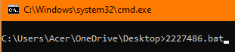
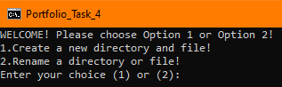

[Insert your picture(s) here] – Directory structure created / menu of batch file (inputs and output when batch file is executed) (10 marks)
- Create:
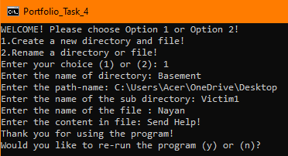
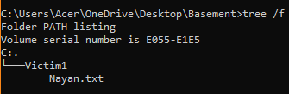
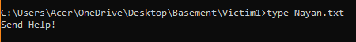

- Rename:
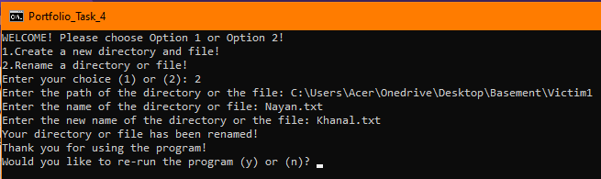
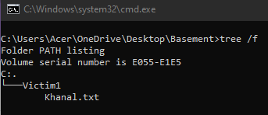

- Wrong Input:
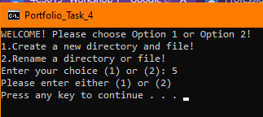
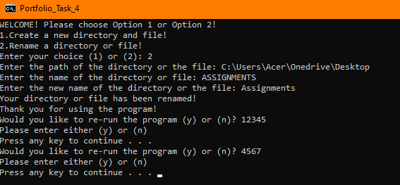

[Insert your text here] – batch file listing (script)(40 marks)
@echo off
cls
title Portfolio_Task_4

:welcome
cls
@echo WELCOME! Please choose Option 1 or Option 2!
@echo 1.Create a new directory and file!
@echo 2.Rename a directory or file!
set /p choice= Enter your choice (1) or (2):
if %choice%==1 Call :create Exit/b
if %choice%==2 Call :rename Exit/b
echo Please enter either (1) or (2)
pause
Call :welcome

:re-run
set /p re-run=Would you like to re-run the program (y) or (n)?
if %re-run%==y Call :welcome
if %re-run%==n exit
echo Please enter either (y) or (n)
pause
Call :re-run

:create
set /p directory=Enter the name of directory:
set /p path=Enter the path-name:
cd %path%
mkdir %directory%
cd %directory%
set /p sub=Enter the name of the sub directory:
mkdir %sub%
cd %sub%
set /p file=Enter the name of the file :
set /p content=Enter the content in file:
echo %content% > %file%.txt
cd../..
@echo Thank you for using the program!
Call :re-run

:rename
set /p path=Enter the path of the directory or the file:
cd %path%
set /p olddirectory=Enter the name of the directory or file:
set /p new=Enter the new name of the directory or the file:
ren %olddirectory% %new%
@echo Your directory or file has been renamed!
cd../..
@echo Thank you for using the program!
Call :re-run
